Vegetation Community Monitoring Protocol for the Heartland Inventory and Monitoring Network

Standard Operating Procedure 5: Monitoring Site Setup

Version 1.00 (2018)

Revision History Log:

| Previous Version # | Revision Date | Author | Changes Made | Reason for Change | New Version # |
| --- | --- | --- | --- | --- | --- |
| 1.00 |  | S.A. Leis | Separated some elements from SOP 3 (2009 version) | Modulate SOPs to reduce redundancy and increase clarity. |  |
|  |  |  |  |  |  |
|  |  |  |  |  |  |
|  |  |  |  |  |  |

Equipment List

* GNSS unit
* Chaining pins (12)
* Compass
* Flagging tape (to make hoops and other equipment easily visible, or mark plants)
* Pin flags (to mark questionable plants)
* Site maps
* Plot hoops (10 m2, 0.01 m2, 0.1 m2 and 1 m2, two sets)
* Site maintenance kit (rebar, tags, wire, yellow caps, hammer, needle nose pliers)
* Metal detector (2) and spare batteries
* Rebar (to replace missing rebar)
* Tagging kit (to replace missing tags)
* Rope and stakes (for use in wooded areas as 10 m2 plot)
* 50 meter tapes (4)

Procedures

See SOP 3-Establishing and Marking Permanent Sample Sites for procedures to navigate and mark site endpoints. Use the GNSS unit to navigate to the site. Once the site is found lay out the transect.

Laying out the transects

Each monitoring site includes two 50 meter transects (A and B) spaced 20 m apart (Figure 5.1) (Although EFMO and PIPE have some single transect sites). The ends of both transects are marked with rebar or nail stakes and metal tags indicating the start and finish. The metal tag on the stake located at the “start” of both transects is marked with the following information: site identification (the number “1, 2, 3….”), transect identification (“A” or “B”) and the letter “S”. The metal tag on the corner marker located at the “finish” of both transects is marked with site identification (the number “1, 2, 3….”), transect identification (“A” or “B”) and the letter “F”. It is absolutely crucial to begin at the start and to know which transect line you are sampling. These two factors relate directly to the location of each plot along the length of the transect.

When searching for the transect markers and laying out measuring tapes, take note of any safety hazards present in the site. For example, patches of poison ivy, briars, holes, standing dead trees. Report the hazards to the project leader, and as a team plan to mitigate or avoid the hazards prior to beginning sampling. Likewise, if a hazard is discovered while collecting data take the time to evaluate the hazard. Consult members of the team as needed. Tools for assisting in decision making include NPS apps and GAR pocket cards.

Figure 5.0. Illustration of a plot with two 50-m transects that are 20 m apart and contain five circles on each. Circles are a 10 meter squared circle and nested 1 meter squared and 0.1 meter squared circles. There are ten of each sized circle in each plot

Figure 5.0. HTLN site showing 50 m long paired transects with 10 systematically arranged plots, 10 m2 in size, for sampling ground flora.

Once both ends of a transect have been located using GNSS and metal detector as needed, insert a stake at the start transect marker with the measuring tape inserted. One person stands at the finish marker while another person pulls the tape from the start toward the finish. In dense communities, a third person may be needed to spot the person pulling the tape making sure the line is straight and tight. Use chaining pins to secure the ends of the tape measure. Using chaining pins rather than the rebar reduces stress on the end of the tape and the rebar. The line is stretched as taut as possible to avoid curvature in the line. Curvature in the line would result in variation in the location of each plot along the line. Under windy conditions this can be a difficult endeavor. During set up, avoid trampling at endpoints, especially AF (50 m) and BS (0 m).

Laying out the nested plots and 10 m2 plots

Herbaceous and shrub species frequency and cover data are collected in five 10 m2 circular plots located along each transect, spaced 10 m apart (Figure 5.0). Along transect A, plots are centered at 10 m, 20 m, 30 m, 40 m and 50 m. Along transect B, plots are centered at 0 m, 10 m, 20 m, 30 m and 40 m. Beginning at the “start” of the transect, the 10 m2 plot, fully assembled, is centered on the first sampling location. The sampling frame is centered by laying the center of the cross-bars that divides the plot into four quarters directly on the taut tape over the desired meter mark. Align one length of the crossbars with the tape stretched between the rebar stakes. At this point, the large outer plot is ready for sampling.

Within the 10 m2 plot are placed three nested circular plots, called nested frequency plots (Figure 5.01. Data are collected using small circular frames, one positioned inside the other and noting the species rooted within. The small frames intentionally favor capturing mostly dominant species so that even small shifts in their abundance may be observed. Sampling includes both species identification and abundance estimation. The plot consists of circular frames :0.01 m2, 0.1 m2 1 m2 nested within the 10m2 plot frame. The nested plots are laid on the edge of the 10 m2 sampling frame, towards the “start” of the transect line where the frame crosses the meter tape. It is important to be diligent about the placement of the plots to ensure consistent sampling from year to year.

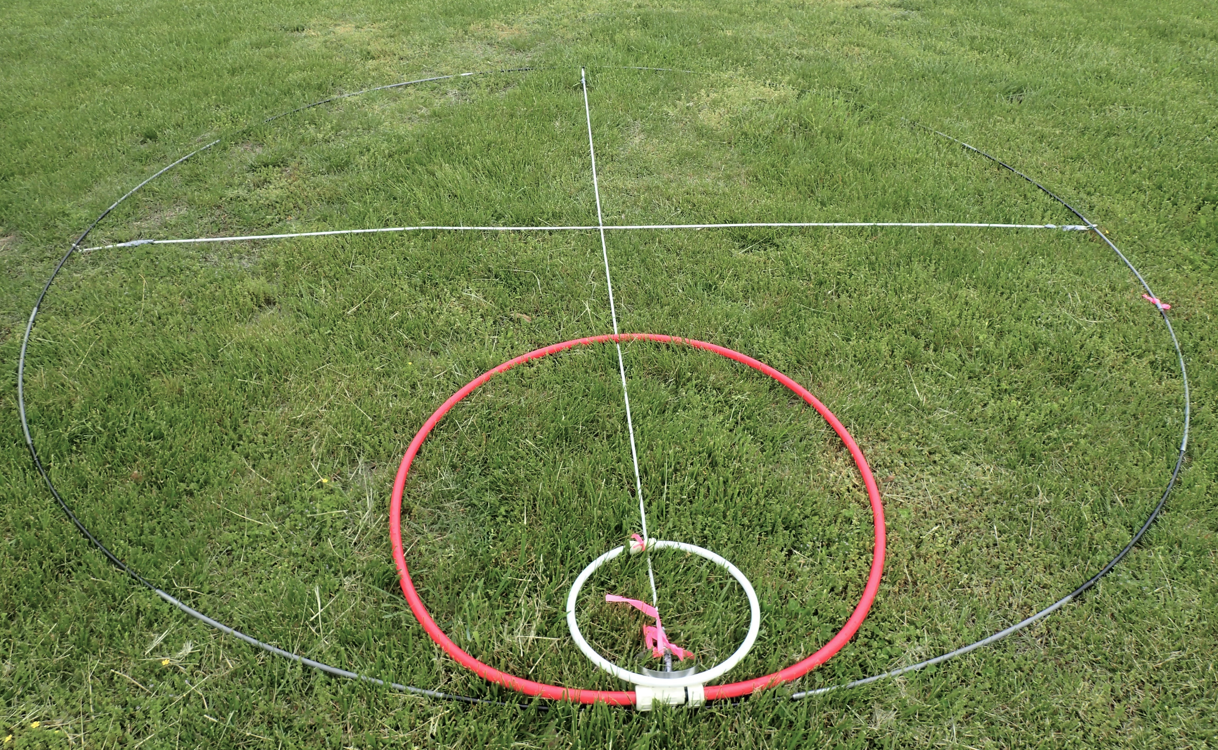

Figure 5.1. Nested hoop frames (0.01, 0.1, and 1.0 m2) withing 10m2 plot frame.

Within woodland sites, it may not be possible to place the 10m2 sampling frame as the result of woody vegetation and obstructions. Instead use stake with measurement rope attached to a pivoting head to measure the 10m2 plot frame (Figure 5.2). Eight to 12 flags are placed to mark the plot using the measurement device.

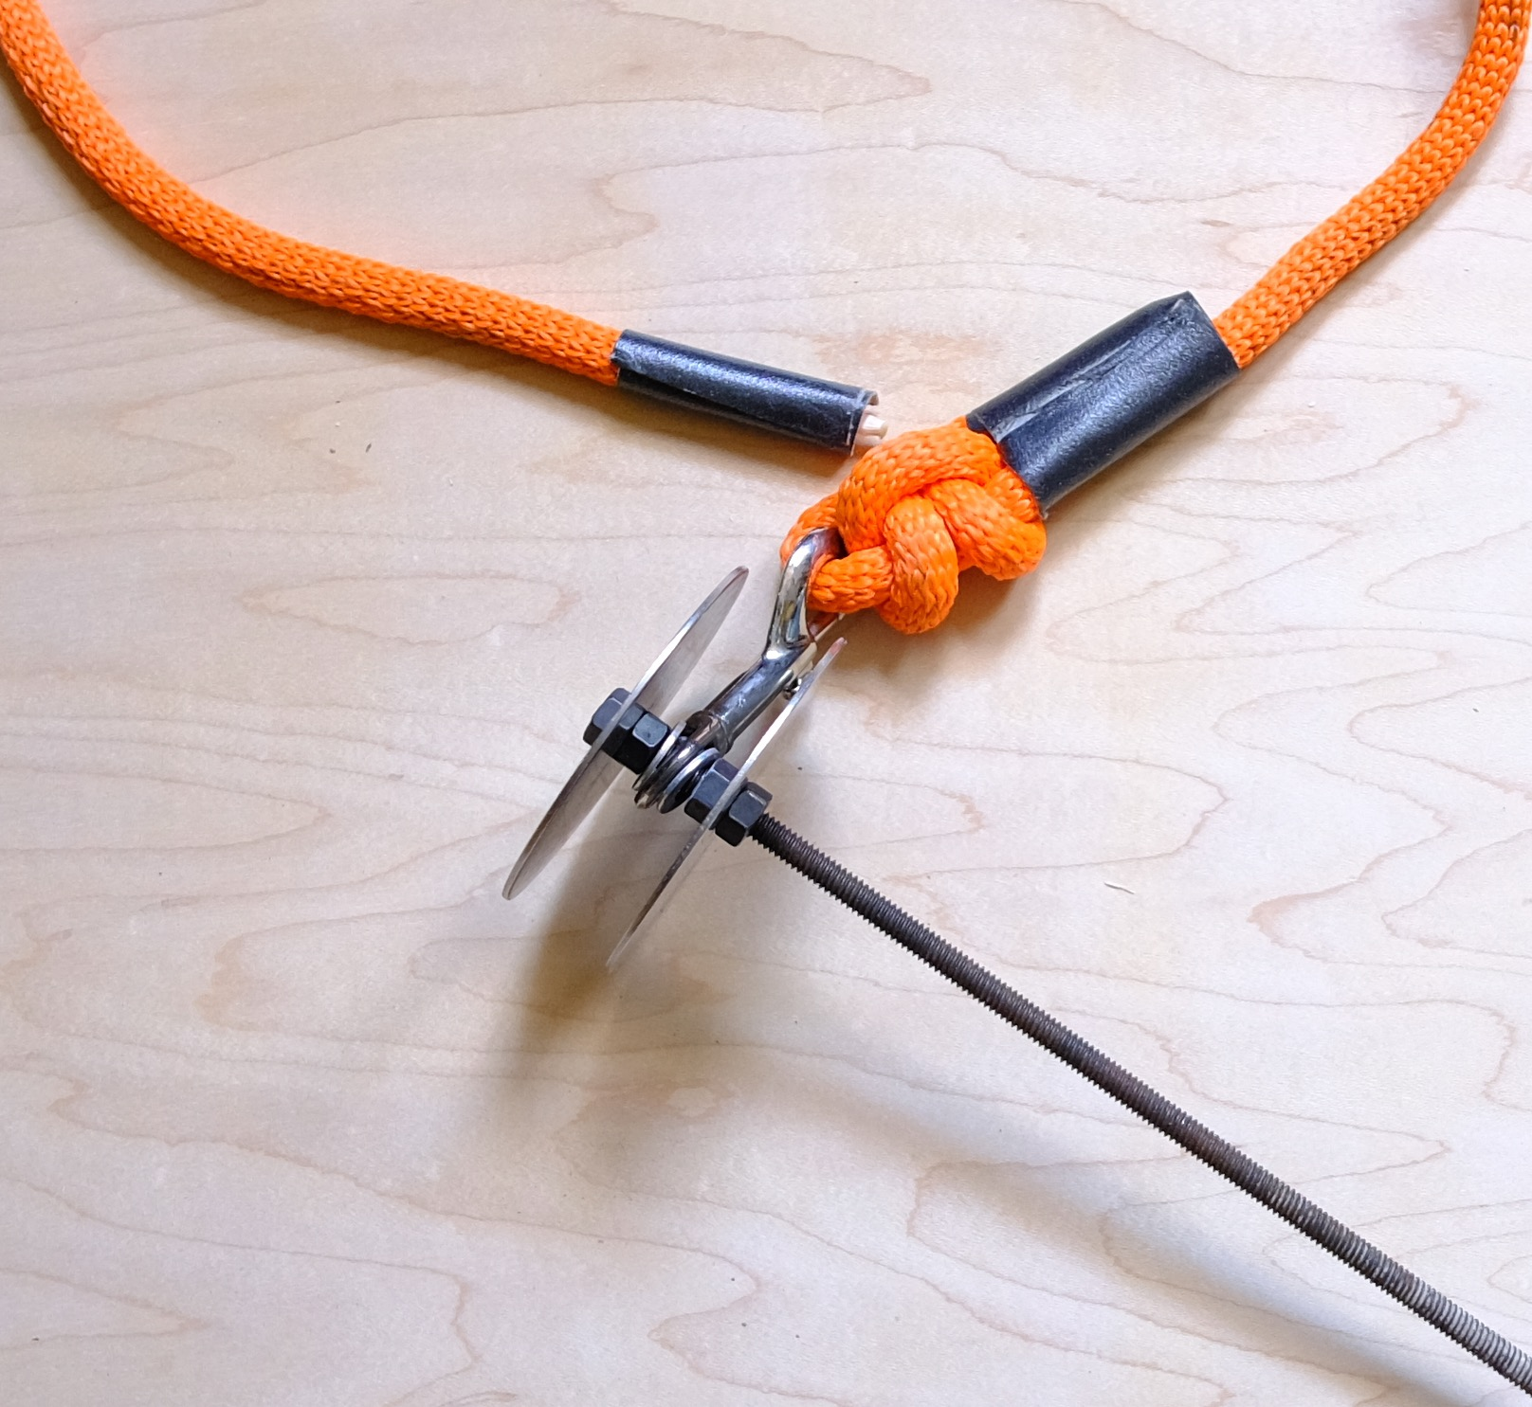

Figure 5.2. Stake with measurement rope attached to a pivoting head used to measure out the 10m2 plot.

Lastly, place a small wire flag at the center point of the plot as well as 8-12 flags around the outside edge of the 10-m2 frame to mark its position. One of these flags should include the position of the overlaid frames on the start side of the plot. See SOP 12-Double Sampling for further information about this. Leave flags in place until the doubling sampling status of the site and plots are known, post initial sampling.

In summary:

1. Pull the transect line as taunt as possible between the two transect at the ends.
2. Consult plot records and transect tags to ensure that the "A" and "B" transect lines (recorded on the tags which are attached to the rebar as "A" and "B") are not reversed.
3. Always start the tape at the beginning of the transect (recorded on the tags around the rebar as "S" for "start").
4. Place the center of each 10 m2 plot where the support bars cross over the designated meter marker or use the stake with rope and pivoting head to measure the plot position,
5. Along transect A, space the 10 m2 plots every 10 m beginning at 10 m, so that the 10 m2 plots are centered on the 10-m, 20-m, 30 m, 40-m and 50-m marks.
6. Along transect B, space the 10 m2 plots every 10 m beginning at 0 m, so that the 10 m2 plots are centered on the 0-m, 10-m, 20-m, 30-m and 40-m marks.
7. Nest the circular 0.01-m2, 0.1-m2 and 1.0-m2 plots where the "edge" of the 10-m2 plot crosses the tape nearest to the "Start" end of the transect.